

ADVANCED JAVA (2160707)
VADODARA INSTITUTE OF ENGINEERING
KOTAMBI

Object Oriented Programming with JAVA (OOPJ) (VI Semester CE)
(Subject Code: 150704)

Lab Manual

Prepared By: Neha Dalwadi CE/IT Department

Index
LABORATORY MANUAL

B.E. Semester-VI

Computer Engineering
And Information Technology

PREPARED BY:
CE/IT DEPARTMENT- 2019-2020
VADODARA INSTITUTE OF ENGINEERING, KOTAMBI-

SR. NO | Experiments | Page No.
1. | Create an application using TCP to implement one way communication.
2. | Create an application using TCP to implement two way communication.
3. | Implement TCP Server for transferring files using Socket and ServerSocket.
4. | User can create a new database and also create new table under that database. Once the database has been created then user can perform database operation  by using Statement and PreparedStatement Interface.
5. | Implement Student information system using JDBC Callable Statement.
6. | Create a Servlet and retrieve Context and Config parameters.
7. | Create Servlet file to insert, update and delete records of particular table of  database.
8. | Write a program to handle cookies.
9. | Write a program to create filter which does pre and post processing.
10. | Write a program to implement useBean action tag.
11. | Write a program to create a Custom tag and use it in a JSP page.
12. | Write a program using connectionless protocol in which the client sends a  string to server and server converts the string into uppercase and sends it back to client.
13. | Write a JSF application to create a login form.
14. | Write a JSF application to insert, update and delete record from database.

Software & Hardware Requirements

Sr.No | Software Requirement | Hardware Requirement
1. | Netbeans 6.9 or later | Processor : Pentium IV
2. | JDK 1.6 or later | RAM : 256 MB
3. | SQL plus (Oracle) 11g | Hard Disk : 40 GB
4. | MySQL 4.0 or Higher Version | Monitor : 15 “

Practical-1

AIM: Create an application using TCP to implement one way communication.

Source Code:
SenderServer.java package mynetworkapp; import java.io.*;
import java.net.*;
import java.util.Scanner; public class SenderServer {
public static void main(String[] args) {
// TODO code application logic here try{
ServerSocket ss=new ServerSocket(4020); System.out.println("wating for client to connect"); Socket s=ss.accept();
System.out.println("connection established");

PrintStream ps=new PrintStream(s.getOutputStream());
BufferedReader kb=new BufferedReader(new InputStreamReader(System.in));

System.out.println("Enter data :"); String str=kb.readLine();
while(!str.equals("exit"))
{ ps.println(str); System.out.println("Enter data :"); str=kb.readLine();
}
ps.close();
s.close();
ss.close();

}catch(IOException e)
{

System.out.println(e);
}
}
}

ReceiverClient.java

package mynetworkapp;
import java.net.InetAddress; import java.net.Socket; import java.util.*;
import java.io.*;
public class ReceiverClient {

public static void main(String[] args) {
// TODO code application logic here try{

// InetAddress ip=InetAddress.getLocalHost(); Socket s=new Socket("localhost",4020);
BufferedReader br=new BufferedReader(new InputStreamReader(s.getInputStream())); String str;
str=br.readLine();
while(str!=null)
{
System.out.println(str); str=br.readLine();
}
br.close();
s.close();
}catch(Exception e)
{
System.out.println(e);
}

}
}

OUTPUT

Server Side
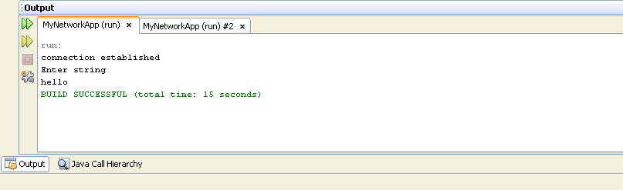

Client Side
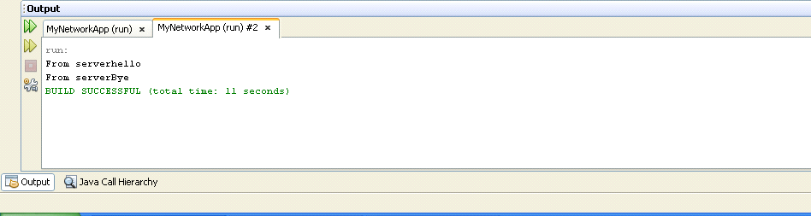

Logical Questions:
- How to establish connection between client and server?
- How to send message from server to client only?

Practical 2

Aim: Create an application using TCP to implement two way communication.

Source Code:
Server.java
/*
- To change this template, choose Tools | Templates
- and open the template in the editor.
*/
package mynetworkapp; import java.io.*;
import java.net.*;

/**

- @author faraahdabhoiwala
*/
public class TwoWayServer1 {
/**
  - @param args the command line arguments
*/
public static void main(String[] args) {
// TODO code application logic here try{
ServerSocket ss=new ServerSocket(4021); System.out.println("Wating for client to connect"); Socket s=ss.accept();
System.out.println("connection established");

BufferedReader br=new BufferedReader(new InputStreamReader(s.getInputStream())); BufferedReader kb=new BufferedReader(new InputStreamReader(System.in)); PrintStream ps=new PrintStream(s.getOutputStream());
String str,str1; str=br.readLine();//read frm client

while(str!=null)
{
System.out.println(str);//reads frm client n writes on server System.out.print("Write something : "); str1=kb.readLine();
ps.println(str1);
str=br.readLine();//reads frm client
}
ps.close();
br.close();
kb.close();
s.close();
ss.close();

}catch(IOException e)
{
System.out.println(e);
}
}
}

Client.java
/*
- To change this template, choose Tools | Templates
- and open the template in the editor.
*/
package mynetworkapp;

import java.io.*; import java.net.*;
/** *
- @author faraahdabhoiwala
*/
public class TwoWayClient1 {

/**
  - @param args the command line arguments
*/

public static void main(String[] args) {
// TODO code application logic here try{
// InetAddress ip= InetAddress.getLocalHost();

Socket s=new Socket("192.168.1.46",4021);
//"192.168.1.47"
BufferedReader br=new BufferedReader(new InputStreamReader(s.getInputStream())); BufferedReader kb=new BufferedReader(new InputStreamReader(System.in)); PrintStream ps=new PrintStream(s.getOutputStream());

System.out.print("write something : "); String str=kb.readLine();
String str1; while(!(str.equals("exit")))
{
ps.println(str);
str1=br.readLine(); System.out.println(str1); System.out.print("write something : "); str=kb.readLine();

}

ps.close();
br.close();
kb.close();
s.close();
System.out.println("client program ended");

}catch(IOException e)
{
System.out.println(e);
}
}
}

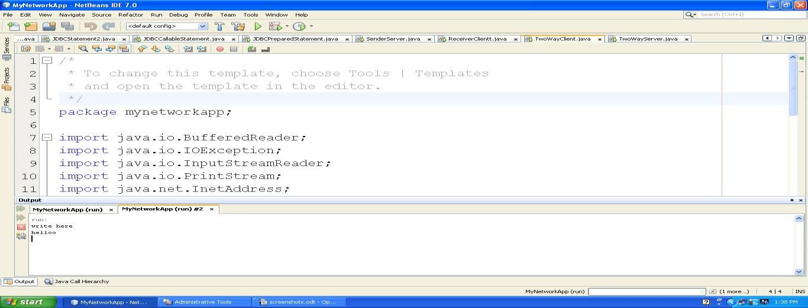
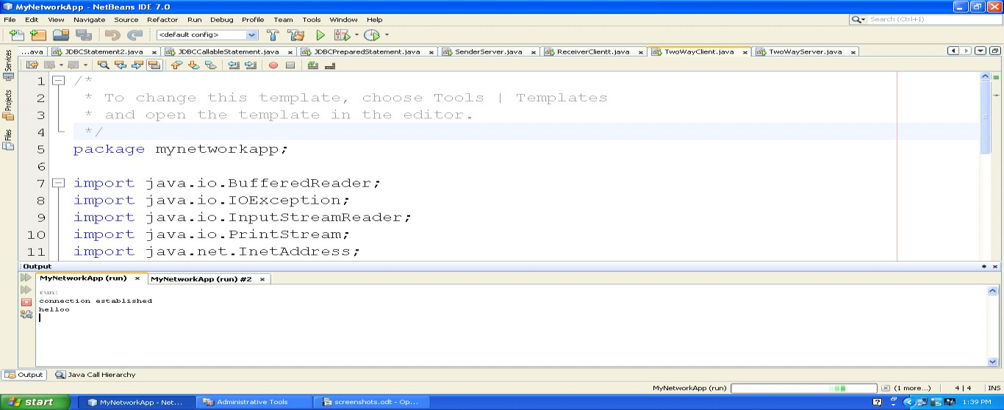
Logical Questions:
- Write a program in which server sends a string and client reply with reverse of that string?
- Write a client server program using TCP where client sends astring and server checks whether that string is palindrome or not and responds with appropriate message.



Practical 3

Aim: Implement TCP Server for transferring files using Socket and ServerSocket.

Source Code:
FileServer.java
/*
- To change this template, choose Tools | Templates
- and open the template in the editor.
*/
package mynetworkapp; import java.io.*;
import java.net.*;

/**

- @author faraahdabhoiwala
*/
public class FileServer {
/**
  - @param args the command line arguments
*/
public static void main(String[] args) {
// TODO code application logic here try{
ServerSocket ss=new ServerSocket(4022); System.out.println("Wating for client to connect"); Socket s=ss.accept();
System.out.println("connection established");

BufferedReader br=new BufferedReader(new InputStreamReader(s.getInputStream())); PrintStream ps=new PrintStream(s.getOutputStream());//client
String fname; fname=br.readLine();

File f=new File(fname); if(f.exists()==true)

{
//FileReader fr=new FileReader(fname);
BufferedReader br1=new BufferedReader(new FileReader(fname)); String str;

str=br1.readLine(); while(str!=null)
{
ps.println(str); str=br1.readLine();
}

br1.close();
}
else
{
ps.println("file doesnt exist");
}
ps.close();
br.close();
s.close();
ss.close();

}catch(IOException e)
{
System.out.println(e);
}
}
}

FileClient.java
/*
- To change this template, choose Tools | Templates
- and open the template in the editor.
*/
package mynetworkapp;

import java.io.*;
import java.net.InetAddress; import java.net.Socket;
/**

- @author faraahdabhoiwala
*/
public class FileClient {

/**
  - @param args the command line arguments
*/
public static void main(String[] args) {
// TODO code application logic here try{
// InetAddress ip= InetAddress.getLocalHost();

Socket s=new Socket("localhost",4022);
//"192.168.1.47"
BufferedReader br=new BufferedReader(new InputStreamReader(s.getInputStream())); BufferedReader kb=new BufferedReader(new InputStreamReader(System.in)); PrintStream ps=new PrintStream(s.getOutputStream());

System.out.print("Enter file name : "); String str=kb.readLine(); ps.println(str);

String st=br.readLine(); while(st!=null)
{
System.out.println(st); st=br.readLine();
}
ps.close();
br.close();
kb.close();
s.close();
System.out.println("client program ended");

}catch(IOException e)
{
System.out.println(e);
}
}
}

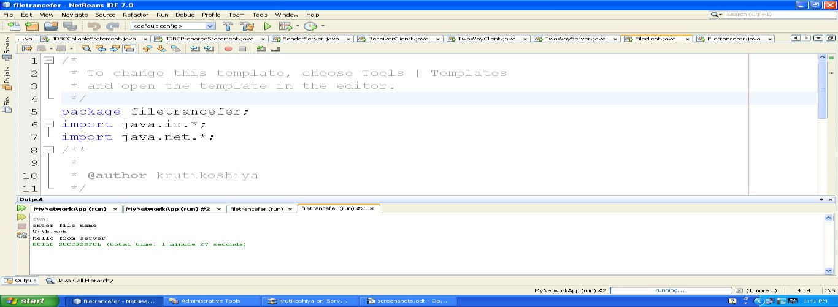
OUTPUT:

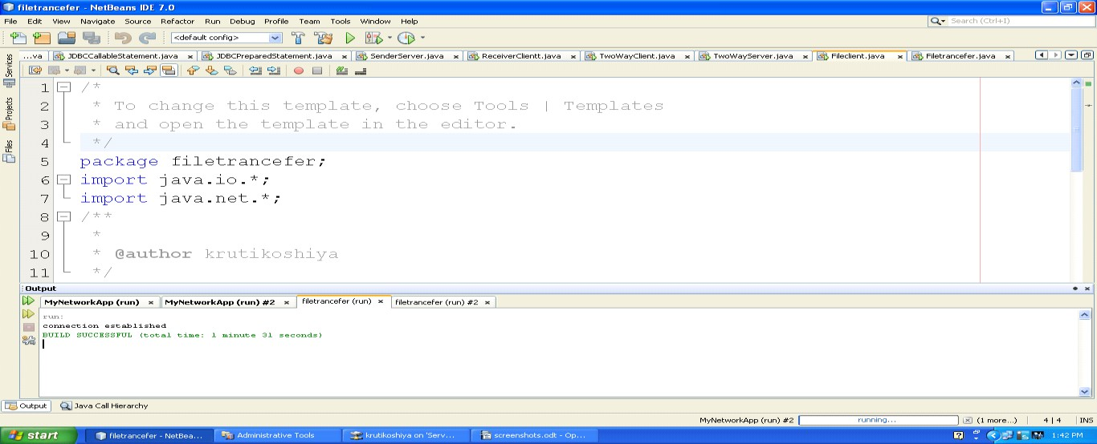
Logical Questions:

- Write a TCP program to access the contents of file at client side.
- Which classes are used for file transfer in socket programming?

Practical 4

Aim: User can create a new database and also create new table under that database. Once the database has been created then user can perform database operation by using Statement and PreparedStatement Interface.

Source Code:

package myfirstapp; import java.sql.*;
public class JDBCStatement {

public static void main(String[] args) {
// TODO code application logic try
{
Class.forName("sun.jdbc.odbc.JdbcOdbcDriver");
Connection con=DriverManager.getConnection("jdbc:odbc:TempDataSource","system","system");
Statement st=con.createStatement();
ResultSet rs=st.executeQuery("select * from student"); while(rs.next())
{

System.out.println(rs.getString("id") + " "+rs.getString("s_name")+ " "+ rs.getString("address"));
}
}catch(SQLException e)
{

System.out.print(e);
}
catch(ClassNotFoundException e)
{
System.out.print(e);
}

}

}

OUTPUT:
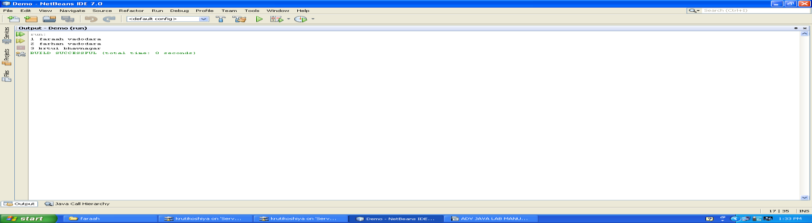

package myfirstapp; import java.sql.*;
public class JDBCStatement2 {
public static void main(String[] args) {
// TODO code application logic int id=6;
String name ="faraah"; String address="vadodara";

try
{
Class.forName("sun.jdbc.odbc.JdbcOdbcDriver");
Connection con=DriverManager.getConnection("jdbc:odbc:TempDataSource","system","system");
Statement st=con.createStatement();
String query="insert into f_student values("+id+",'"+name+"','"+address+"')"; int count=st.executeUpdate(query);
System.out.println("No of rows updated="+count);

}catch(Exception e)
{

System.out.print(e);
}

}
}
OUTPUT:
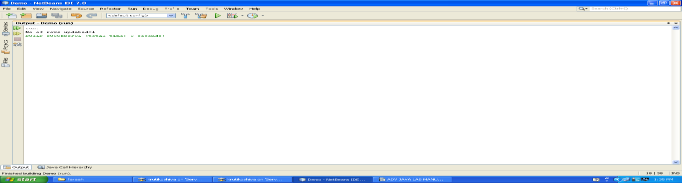

/*
- To change this template, choose Tools | Templates
- and open the template in the editor.
*/
package myfirstapp; import java.sql.*;
/**

- @author faraahdabhoiwala
*/
public class JDBCPreparedStatement {
/**
  - @param args the command line arguments
*/
public static void main(String[] args) {
// TODO code application logic here try
{
Class.forName("sun.jdbc.odbc.JdbcOdbcDriver");
Connection con=DriverManager.getConnection("jdbc:odbc:TempDataSource","system","system");

PreparedStatement ps=con.prepareStatement("select * from f_student where name like ? or name like ?");

ps.setString(1, "r%");
ps.setString(2, "j%");
ResultSet rs=ps.executeQuery(); while(rs.next())
{

System.out.println(rs.getString("id")+ " "+rs.getString("name")+" "+rs.getString("address"));
}

}catch(Exception e)
{

System.out.print(e);
}
}
}

Using PreparedStatement Interface:-
/*
- To change this template, choose Tools | Templates
- and open the template in the editor.
*/
package myfirstapp; import java.sql.*;
/**

- @author faraahdabhoiwala
*/
public class JDBCPreparedStatement {
/**
  - @param args the command line arguments
*/
public static void main(String[] args) {
// TODO code application logic here try

{
Class.forName("sun.jdbc.odbc.JdbcOdbcDriver"); Connection
con=DriverManager.getConnection("jdbc:odbc:TempDataSource","system","system");

?");
PreparedStatement ps=con.prepareStatement("select * from f_student name like ? or name like
ps.setString(1, "k%");
ps.setString(2, "f%");
ResultSet rs=ps.executeQuery(); while(rs.next())
{

System.out.println(rs.getString("id")+ " "+rs.getString("name")+" "+rs.getString("address"));
}
}catch(Exception e)
{

System.out.print(e);
}
}
}
OUTPUT:
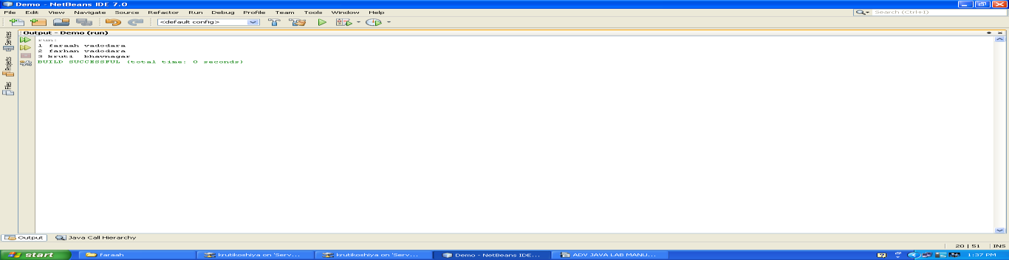

Logical Questions:
- What is the difference between statement and prepared statement?
- How prepared statement is better than statement interface?
- Insert the data in the database by using prepared statement interface.

Practical 5

Aim: Implement Student information system using JDBC Callable Statement.

Source Code:
package myfirstapp;

import java.sql.*; import java.util.Scanner;
/**
*
- @author faraahdabhoiwala
*/
public class JDBCCallableStatement {
/**
  - @param args the command line arguments
*/
public static void main(String[] args) {
// TODO code application logic here
try
{
//Scanner sc=new Scanner(System.in);
//System.out.print("enter name");
String name="vrushil11"; int enr=13;
int sem=5;
String add="kotambi"; int per=99;
Class.forName("sun.jdbc.odbc.JdbcOdbcDriver");

Connection con=DriverManager.getConnection("jdbc:odbc:TempDataSource","system","system");
CallableStatement cs=con.prepareCall("call add_student_details (?,?,?,?,?)"); cs.setInt(1, enr);
cs.setString(2, name); cs.setInt(3,sem);

cs.setString(4, add); cs.setInt(5, per);
cs.execute(); System.out.println("Data entered");
}catch(SQLException e)
{
System.out.print(e);
}
catch(ClassNotFoundException e)
{
System.out.print(e);
}
}
}
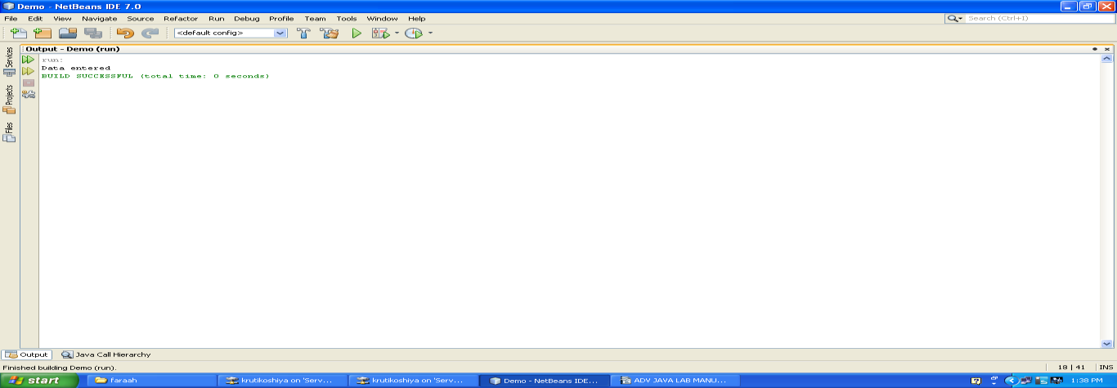
OUTPUT:

Using OUT parameters in CallableStatement Interface:-
package myfirstapp;
import java.sql.*; import java.util.Scanner
/**

- @author faraahdabhoiwala
*/
public class JDBCCallableOUT
/**
  - @param args the command line arguments
*/

public static void main(String[] args) {
// TODO code application logic
Scanner sc=new Scanner(System.in); System.out.println("Enter id :");
int id=sc.nextInt(); try {
Class.forName("sun.jdbc.odbc.JdbcOdbcDriver");
Connection con=DriverManager.getConnection("jdbc:odbc:TempDataSource","system","system"); CallableStatement cs=con.prepareCall("{call getStudentMarks(?,?)}");
cs.setInt(1,id);
cs.registerOutParameter(2, Types.INTEGER); cs.execute();
int percentage=cs.getInt(2); System.out.println("marks ="+percentage);
} catch (Exception e) { System.out.println(e);
} }}

OUTPUT:
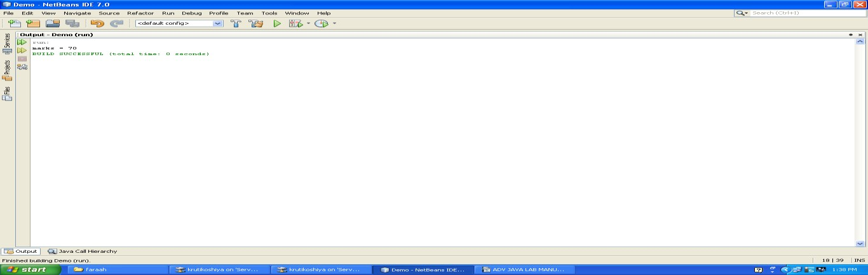

Logical Questions:

- What is Stored Procedure?
- How to execute more than one query by using callable statement interface?
- Update the record in the database by using callable statement interface.

Practical 6

Aim: Create a Servlet and retrieve Context and Config parameters.

Source Code:
index.jsp
<%--
Document : index
Created on : Feb 16, 2016, 10:37:58 AM Author : faraahdabhoiwala
--%>
<%@page contentType="text/html" pageEncoding="UTF-8"%>
<!DOCTYPE html>
<html>
<head>
<meta http-equiv="Content-Type" content="text/html; charset=UTF-8">
<title>JSP Page</title>
</head>
<body>
<a href="RetriveParam"> Go to MyServlet</a>
</body>
</html>

WEB-INF

<?xml version="1.0" encoding="UTF-8"?>
<web-app version="3.0" xmlns="http://java.sun.com/xml/ns/javaee" xmlns:xsi="http://www.w3.org/2001/XMLSchema-instance" xsi:schemaLocation="http://java.sun.com/xml/ns/javaee http://java.sun.com/xml/ns/javaee/web- app_3_0.xsd">
<context-param>
<param-name>admin</param-name>
<param-value>dhaval</param-value>
</context-param>
<context-param>
<param-name>user</param-name>
<param-value>saifali</param-value>
</context-param>
<servlet>
<servlet-name>RetriveParam</servlet-name>
<servlet-class>RetriveParam</servlet-class>
<init-param>
<param-name>country</param-name>
<param-value>india</param-value>

</init-param>
<init-param>
<param-name>college</param-name>
<param-value>vier</param-value>
</init-param>
<init-param>
<param-name>s_name</param-name>
<param-value>nirlay</param-value>
</init-param>
</servlet>
<servlet-mapping>
<servlet-name>RetriveParam</servlet-name>
<url-pattern>/RetriveParam</url-pattern>
</servlet-mapping>
<session-config>
<session-timeout> 30
</session-timeout>
</session-config>
</web-app>

RetriveParam.java
/*
- To change this template, choose Tools | Templates
- and open the template in the editor.
*/

import java.io.IOException; import java.io.PrintWriter;
import javax.servlet.ServletConfig; import javax.servlet.ServletException; import javax.servlet.http.HttpServlet;
import javax.servlet.http.HttpServletRequest; import javax.servlet.http.HttpServletResponse; import javax.servlet.*;
import java.util.*;
/**

- @author faraahdabhoiwala
*/
public class RetriveParam extends HttpServlet {
/**
  - Processes requests for both HTTP <code>GET</code> and <code>POST</code> methods.
  - @param request servlet request
  - @param response servlet response

  - @throws ServletException if a servlet-specific error occurs
  - @throws IOException if an I/O error occurs
*/
protected void processRequest(HttpServletRequest request, HttpServletResponse response) throws ServletException, IOException {
response.setContentType("text/html;charset=UTF-8"); PrintWriter out = response.getWriter();
ServletConfig sc=this.getServletConfig();
Enumeration e=sc.getInitParameterNames(); while(e.hasMoreElements())
{
String str=(String)e.nextElement();//name of param out.print("<br><b>"+sc.getInitParameter(str));//value
}
ServletContext sc1=this.getServletContext();

Enumeration e1=sc1.getInitParameterNames(); while(e1.hasMoreElements())
{
String str1=(String)e1.nextElement();//name of param out.print("<br>"+str1); out.print("<br><b>"+sc1.getInitParameter(str1));//value

}
}
// <editor-fold defaultstate="collapsed" desc="HttpServlet methods. Click on the + sign on the left to edit the code.">
/**
  - Handles the HTTP <code>GET</code> method.
  - @param request servlet request
  - @param response servlet response
  - @throws ServletException if a servlet-specific error occurs
  - @throws IOException if an I/O error occurs
*/ @Override
protected void doGet(HttpServletRequest request, HttpServletResponse response) throws ServletException, IOException {
processRequest(request, response);
}
/**
  - Handles the HTTP <code>POST</code> method.

  - @param request servlet request
  - @param response servlet response
  - @throws ServletException if a servlet-specific error occurs
  - @throws IOException if an I/O error occurs
*/ @Override
protected void doPost(HttpServletRequest request, HttpServletResponse response) throws ServletException, IOException {
processRequest(request, response);
}
/**
  - Returns a short description of the servlet.
  - @return a String containing servlet description
*/ @Override
public String getServletInfo() { return "Short description";
}// </editor-fold>
}

OUTPUT:

dhaval saifali

india vier nirlay

Logical Questions:

- Write a program for getting all the initialization parameter from the web.xml file and printing this information in the servlet.
- Which methods are used for ServletContext and ServletConfig?

Practical 7

Aim: Create Servlet file to insert, update and delete records of particular table of database.

Source Code:

Student.html
<!--
To change this template, choose Tools | Templates and open the template in the editor.
-->
<!DOCTYPE html>
<html>
<head>
<title></title>
<meta http-equiv="Content-Type" content="text/html; charset=UTF-8">
</head>
<body>

<form action="JDBCServlet">
Name<input type="text" name="name"></input>
<br>
Enrollment NO<input type="text" name="enr"></input>
<br>
Semester<input type="text" name="sem"></input>
<br>
<input type="submit" value="insert" name="submit"></input>

<input type="submit" value="update" name="submit"></input>
<input type="submit" value="delete" name="submit"></input>
</form>
</body>
</html>

JDBCServlet.java
/*
- To change this template, choose Tools | Templates
- and open the template in the editor.
*/
import java.io.IOException; import java.io.PrintWriter;
import javax.servlet.ServletException; import javax.servlet.http.HttpServlet;
import javax.servlet.http.HttpServletRequest; import javax.servlet.http.HttpServletResponse; import java.sql.*;

/**

- @author faraahdabhoiwala
*/
public class JDBCServlet extends HttpServlet { int enr,sem;
String name;
/**
  - Processes requests for both HTTP <code>GET</code> and <code>POST</code> methods.
  - @param request servlet request
  - @param response servlet response
  - @throws ServletException if a servlet-specific error occurs
  - @throws IOException if an I/O error occurs
*/
protected void processRequest(HttpServletRequest request, HttpServletResponse response) throws ServletException, IOException {
response.setContentType("text/html;charset=UTF-8"); PrintWriter out = response.getWriter();
enr=Integer.parseInt(request.getParameter("enr")); name=request.getParameter("name"); sem=Integer.parseInt(request.getParameter("sem"));
String str=request.getParameter("submit"); if(str.equals("insert"))
{
String s=insertData();
out.println("<br> "+s);
}
else if(str.equals("update"))
{

updateData();
out.println("<br> data updated successfully");
}
else if(str.equals("delete"))
{
deleteData();
out.println("<br> data deleted successfully");
}
}

public String insertData()
{ try
{
Class.forName("sun.jdbc.odbc.JdbcOdbcDriver");
Connection con=DriverManager.getConnection("jdbc:odbc:TempDataSource","system","system");
Statement st=con.createStatement();
String query="insert into f_student values("+enr+",'"+name+"',"+sem+")";
int count=st.executeUpdate(query); return "data inserted succesfully";
}catch(Exception e)
{
return e.toString();
}
}
public void updateData()
{ try
{
Class.forName("sun.jdbc.odbc.JdbcOdbcDriver");
Connection con=DriverManager.getConnection("jdbc:odbc:TempDataSource","system","system");
Statement st=con.createStatement();
String query="update f_student set name='"+name+"' where enr="+enr+""; int count=st.executeUpdate(query);

}catch(Exception e)
{
System.out.print(e);
}
}
public void deleteData()
{ try
{
Class.forName("sun.jdbc.odbc.JdbcOdbcDriver");
Connection con=DriverManager.getConnection("jdbc:odbc:TempDataSource","system","system");
Statement st=con.createStatement();
String query="delete from f_student where enr="+enr+""; int count=st.executeUpdate(query);

}catch(Exception e)
{
System.out.print(e);
}
}

// <editor-fold defaultstate="collapsed" desc="HttpServlet methods. Click on the + sign on the left to edit the code.">
/**
  - Handles the HTTP <code>GET</code> method.
  - @param request servlet request
  - @param response servlet response
  - @throws ServletException if a servlet-specific error occurs
  - @throws IOException if an I/O error occurs
*/ @Override
protected void doGet(HttpServletRequest request, HttpServletResponse response) throws ServletException, IOException {
processRequest(request, response);
}
/**
  - Handles the HTTP <code>POST</code> method.
  - @param request servlet request
  - @param response servlet response
  - @throws ServletException if a servlet-specific error occurs
  - @throws IOException if an I/O error occurs
*/ @Override
protected void doPost(HttpServletRequest request, HttpServletResponse response) throws ServletException, IOException {
processRequest(request, response);
}
/**
  - Returns a short description of the servlet.
  - @return a String containing servlet description
*/ @Override
public String getServletInfo() { return "Short description";
}// </editor-fold>
}

OUTPUT:

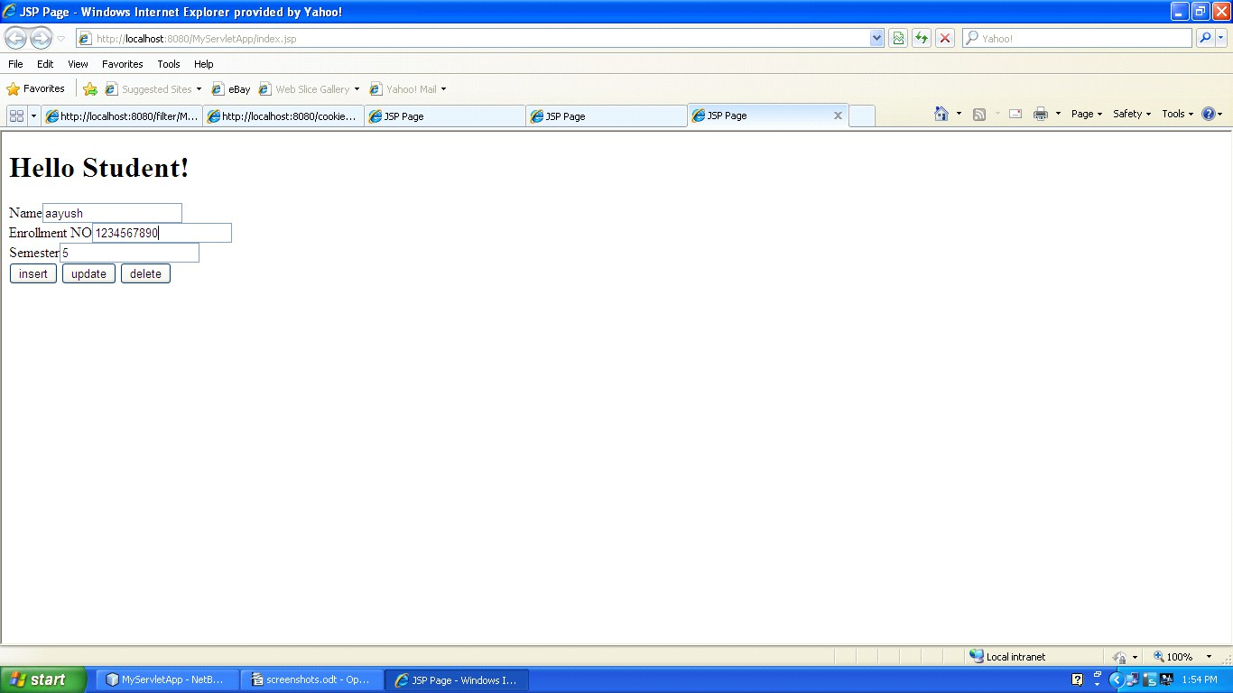
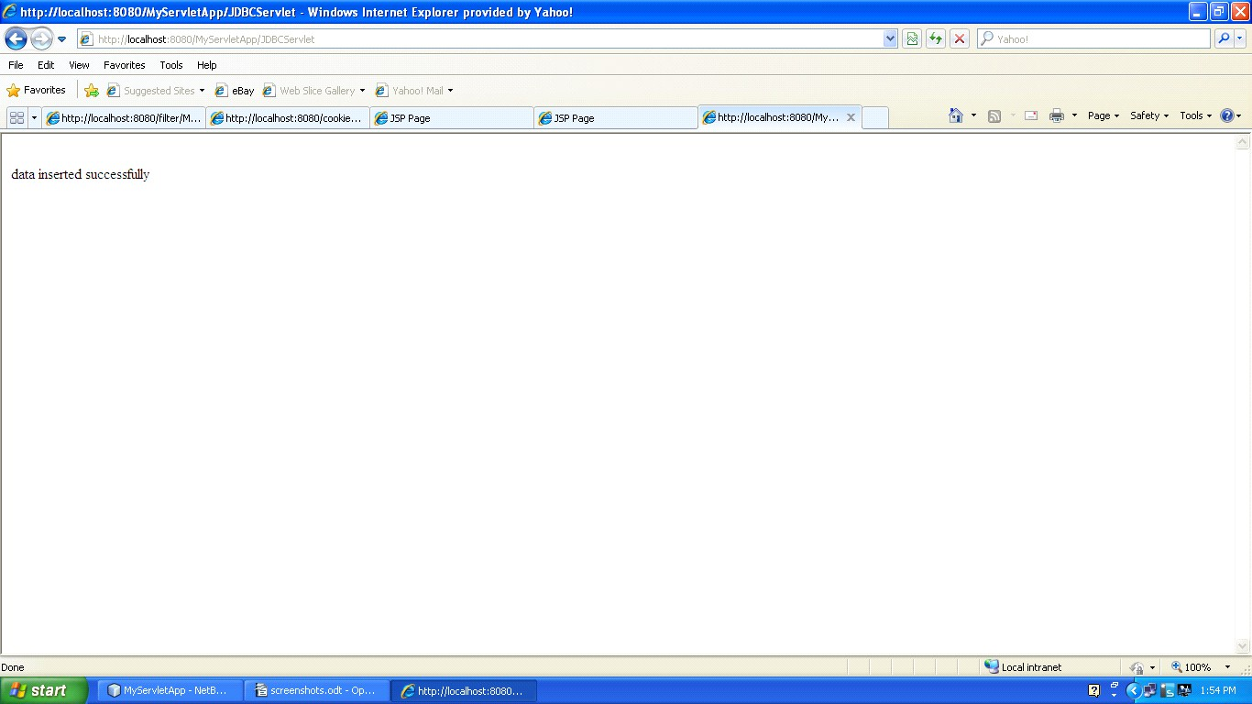
Logical Questions:
- Hw we can insert the record in the database by using servlet?
- .Hw we can update the record in the database by using servlet?

Practical 8
Aim: Write a program to handle cookies.

Source Code:
SessionCookies.jsp
<%--
Document : SessionCookies
Created on : Feb 19, 2016, 11:57:27 AM Author : faraahdabhoiwala
--%>
<%@page contentType="text/html" pageEncoding="UTF-8"%>
<!DOCTYPE html>
<html>
<head>
<meta http-equiv="Content-Type" content="text/html; charset=UTF-8">
<title>JSP Page</title>
<a href="SessionCookies">Retrive My Cookies</a>
</head>
<body>
<h1>Hello World!</h1>
</body>
</html>

SessionCookies.java
/*
- To change this template, choose Tools | Templates
- and open the template in the editor.
*/

import java.io.IOException; import java.io.PrintWriter;
import javax.servlet.ServletException; import javax.servlet.http.Cookie; import javax.servlet.http.HttpServlet;
import javax.servlet.http.HttpServletRequest; import javax.servlet.http.HttpServletResponse; import javax.servlet.http.HttpSession;
/**

- @author faraahdabhoiwala

*/
public class SessionCookies extends HttpServlet {
/**
  - Processes requests for both HTTP <code>GET</code> and <code>POST</code> methods.
  - @param request servlet request
  - @param response servlet response
  - @throws ServletException if a servlet-specific error occurs
  - @throws IOException if an I/O error occurs
*/
protected void processRequest(HttpServletRequest request, HttpServletResponse response) throws ServletException, IOException {
response.setContentType("text/html;charset=UTF-8"); PrintWriter out = response.getWriter();

Cookie c1=new Cookie("username","faraah"); Cookie c2=new Cookie("password","f1234");

response.addCookie(c1); response.addCookie(c2); Cookie[] c=request.getCookies(); for(int i=0;i<c.length;i++)
{
out.println("<br>name of cookie is"+c[i].getName()+"value="+c[i].getValue());
}
}
// <editor-fold defaultstate="collapsed" desc="HttpServlet methods. Click on the + sign on the left to edit the code.">
/**
  - Handles the HTTP <code>GET</code> method.
  - @param request servlet request
  - @param response servlet response
  - @throws ServletException if a servlet-specific error occurs
  - @throws IOException if an I/O error occurs
*/ @Override
protected void doGet(HttpServletRequest request, HttpServletResponse response) throws ServletException, IOException {
processRequest(request, response);
}
/**
  - Handles the HTTP <code>POST</code> method.

  - @param request servlet request
  - @param response servlet response
  - @throws ServletException if a servlet-specific error occurs
  - @throws IOException if an I/O error occurs
*/ @Override
protected void doPost(HttpServletRequest request, HttpServletResponse response) throws ServletException, IOException {
processRequest(request, response);
}
/**
  - Returns a short description of the servlet.
  - @return a String containing servlet description
*/ @Override
public String getServletInfo() { return "Short description";
}// </editor-fold>
}
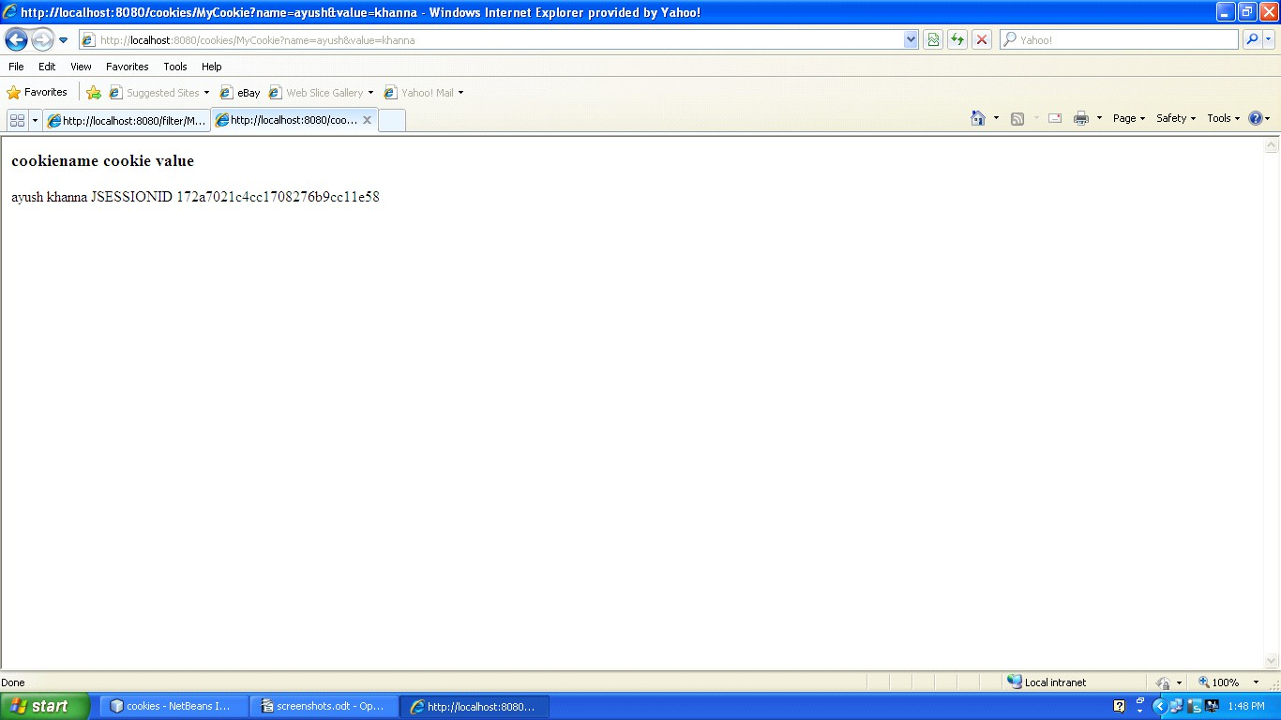

Logical Questions:

- To add the cookie in the browser, which method is used?
- .How to retrieve the cookie value on browser?

Practical 9

Aim: Write a program to create filter which does pre and post processing.

Source Code:

newhtml.html
<!--
To change this template, choose Tools | Templates and open the template in the editor.
-->
<!DOCTYPE html>
<html>
<head>
<title></title>
<meta http-equiv="Content-Type" content="text/html; charset=UTF-8">
</head>
<body>
<div>TODO write content</div>
<a href="testServlet">go to my filter</a>
</body>
</html>

MyFilter.java
/*
- To change this template, choose Tools | Templates
- and open the template in the editor.
*/
import java.io.IOException; import java.io.PrintStream; import java.io.PrintWriter; import java.io.StringWriter; import javax.servlet.Filter; import javax.servlet.FilterChain; import javax.servlet.FilterConfig;
import javax.servlet.ServletException; import javax.servlet.ServletRequest; import javax.servlet.ServletResponse;
/**

- @author faraahdabhoiwala
*/
public class MyFilter implements Filter {
private static final boolean debug = true;
// The filter configuration object we are associated with. If

// this value is null, this filter instance is not currently
// configured.
private FilterConfig filterConfig = null;

public MyFilter() {
}
private void doBeforeProcessing(ServletRequest request, ServletResponse response) throws IOException, ServletException {
if (debug) { log("MyFilter:DoBeforeProcessing");
}

// Write code here to process the request and/or response before
// the rest of the filter chain is invoked.
// For example, a logging filter might log items on the request object,
// such as the parameters.
/*
for (Enumeration en = request.getParameterNames(); en.hasMoreElements(); ) { String name = (String)en.nextElement();
String values[] = request.getParameterValues(name); int n = values.length;
StringBuffer buf = new StringBuffer(); buf.append(name);
buf.append("="); for(int i=0; i < n; i++) { buf.append(values[i]); if (i < n-1) buf.append(",");
}
log(buf.toString());
}
*/
}
private void doAfterProcessing(ServletRequest request, ServletResponse response) throws IOException, ServletException {
if (debug) { log("MyFilter:DoAfterProcessing");
}

// Write code here to process the request and/or response after
// the rest of the filter chain is invoked.
// For example, a logging filter might log the attributes on the
// request object after the request has been processed.

/*
for (Enumeration en = request.getAttributeNames(); en.hasMoreElements(); ) { String name = (String)en.nextElement();
Object value = request.getAttribute(name); log("attribute: " + name + "=" + value.toString());
}
*/
// For example, a filter might append something to the response.
/*
PrintWriter respOut = new PrintWriter(response.getWriter()); respOut.println("<P><B>This has been appended by an intrusive filter.</B>");
*/
}
/**
*
  - @param request The servlet request we are processing
  - @param response The servlet response we are creating
  - @param chain The filter chain we are processing

  - @exception IOException if an input/output error occurs
  - @exception ServletException if a servlet error occurs
*/
public void doFilter(ServletRequest request, ServletResponse response, FilterChain chain)
throws IOException, ServletException {
if (debug) { log("MyFilter:doFilter()");
}
doBeforeProcessing(request, response); PrintWriter out=response.getWriter(); out.print("<br>hi from filter"); Throwable problem = null;
try {
chain.doFilter(request, response);
} catch (Throwable t) {
// If an exception is thrown somewhere down the filter chain,
// we still want to execute our after processing, and then
// rethrow the problem after that. problem = t; t.printStackTrace();
}

doAfterProcessing(request, response); out.print("<br> after processing bye from filter");
// If there was a problem, we want to rethrow it if it is
// a known type, otherwise log it. if (problem != null) {
if (problem instanceof ServletException) { throw (ServletException) problem;
}
if (problem instanceof IOException) { throw (IOException) problem;
}
sendProcessingError(problem, response);
}
}
/**
  - Return the filter configuration object for this filter.
*/
public FilterConfig getFilterConfig() { return (this.filterConfig);
}
/**
  - Set the filter configuration object for this filter.

  - @param filterConfig The filter configuration object
*/
public void setFilterConfig(FilterConfig filterConfig) { this.filterConfig = filterConfig;
}
/**
  - Destroy method for this filter
*/
public void destroy() {
}
/**
  - Init method for this filter
*/
public void init(FilterConfig filterConfig) { this.filterConfig = filterConfig;
if (filterConfig != null) { if (debug) {
log("MyFilter:Initializing filter");
}
}

}
/**
  - Return a String representation of this object.
*/ @Override
public String toString() {
if (filterConfig == null) { return ("MyFilter()");
}
StringBuffer sb = new StringBuffer("MyFilter("); sb.append(filterConfig);
sb.append(")"); return (sb.toString());
}
private void sendProcessingError(Throwable t, ServletResponse response) { String stackTrace = getStackTrace(t);

if (stackTrace != null && !stackTrace.equals("")) { try {
response.setContentType("text/html");
PrintStream ps = new PrintStream(response.getOutputStream()); PrintWriter pw = new PrintWriter(ps);
pw.print("<html>\n<head>\n<title>Error</title>\n</head>\n<body>\n"); //NOI18N

// PENDING! Localize this for next official release
pw.print("<h1>The resource did not process correctly</h1>\n<pre>\n"); pw.print(stackTrace);
pw.print("</pre></body>\n</html>"); //NOI18N pw.close();
ps.close(); response.getOutputStream().close();
} catch (Exception ex) {
}
} else { try {
PrintStream ps = new PrintStream(response.getOutputStream()); t.printStackTrace(ps);
ps.close(); response.getOutputStream().close();
} catch (Exception ex) {
}
}
}
public static String getStackTrace(Throwable t) {

String stackTrace = null; try {
StringWriter sw = new StringWriter(); PrintWriter pw = new PrintWriter(sw); t.printStackTrace(pw);
pw.close();
sw.close();
stackTrace = sw.getBuffer().toString();
} catch (Exception ex) {
}
return stackTrace;
}

public void log(String msg) { filterConfig.getServletContext().log(msg);
}
}

MyServlet.java
/*
- To change this template, choose Tools | Templates
- and open the template in the editor.
*/
import java.io.IOException; import java.io.PrintWriter;
import javax.servlet.ServletException; import javax.servlet.http.HttpServlet;
import javax.servlet.http.HttpServletRequest; import javax.servlet.http.HttpServletResponse;
/**

- @author faraahdabhoiwala
*/
public class MyServlet extends HttpServlet {
/**
  - Processes requests for both HTTP <code>GET</code> and <code>POST</code> methods.
  - @param request servlet request
  - @param response servlet response
  - @throws ServletException if a servlet-specific error occurs
  - @throws IOException if an I/O error occurs
*/
protected void processRequest(HttpServletRequest request, HttpServletResponse response) throws ServletException, IOException {
response.setContentType("text/html;charset=UTF-8");

PrintWriter out = response.getWriter(); out.print("<br>hello from servlet");
}

// <editor-fold defaultstate="collapsed" desc="HttpServlet methods. Click on the + sign on the left to edit the code.">
/**
  - Handles the HTTP <code>GET</code> method.
  - @param request servlet request
  - @param response servlet response
  - @throws ServletException if a servlet-specific error occurs
  - @throws IOException if an I/O error occurs
*/ @Override
protected void doGet(HttpServletRequest request, HttpServletResponse response) throws ServletException, IOException {
processRequest(request, response);
}

/**
  - Handles the HTTP <code>POST</code> method.
  - @param request servlet request
  - @param response servlet response
  - @throws ServletException if a servlet-specific error occurs
  - @throws IOException if an I/O error occurs
*/ @Override
protected void doPost(HttpServletRequest request, HttpServletResponse response) throws ServletException, IOException {
processRequest(request, response);
}
/**
  - Returns a short description of the servlet.
  - @return a String containing servlet description
*/ @Override
public String getServletInfo() { return "Short description";
}// </editor-fold>
}

WEB-INF

<?xml version="1.0" encoding="UTF-8"?>

<web-app version="3.0" xmlns="http://java.sun.com/xml/ns/javaee" xmlns:xsi="http://www.w3.org/2001/XMLSchema-instance" xsi:schemaLocation="http://java.sun.com/xml/ns/javaee http://java.sun.com/xml/ns/javaee/web- app_3_0.xsd">
<context-param>
<param-name>admin</param-name>
<param-value>khyati</param-value>
</context-param>
<context-param>
<param-name>user</param-name>
<param-value>sunny</param-value>
</context-param>
<filter>
<filter-name>MyFilter</filter-name>
<filter-class>MyFilter</filter-class>
</filter>
<filter>
<filter-name>StudentFilter</filter-name>
<filter-class>StudentFilter</filter-class>
</filter>
<filter-mapping>
<filter-name>StudentFilter</filter-name>
<servlet-name>StudentServlet</servlet-name>
</filter-mapping>
<servlet>
<servlet-name>StudentServlet</servlet-name>
<servlet-class>StudentServlet</servlet-class>
</servlet>
<filter-mapping>
<filter-name>MyFilter</filter-name>
<servlet-name>MyServlet</servlet-name>
</filter-mapping>
<servlet>
<servlet-name>RetriveContextParam</servlet-name>
<servlet-class>RetriveContextParam</servlet-class>
<init-param>
<param-name>country</param-name>
<param-value>india</param-value>
</init-param>
<init-param>
<param-name>state</param-name>
<param-value>gujarat</param-value>
</init-param>
</servlet>
<servlet>
<servlet-name>SessionCookies</servlet-name>

<servlet-class>SessionCookies</servlet-class>
</servlet>
<servlet>
<servlet-name>testcookie</servlet-name>
<servlet-class>testcookie</servlet-class>
</servlet>
<servlet>
<servlet-name>URLRewriting</servlet-name>
<servlet-class>URLRewriting</servlet-class>
</servlet>
<servlet>
<servlet-name>JDBCServlet</servlet-name>
<servlet-class>JDBCServlet</servlet-class>
</servlet>
<servlet>
<servlet-name>MyServlet</servlet-name>
<servlet-class>MyServlet</servlet-class>
</servlet>

<servlet-mapping>
<servlet-name>RetriveContextParam</servlet-name>
<url-pattern>/RetriveContextParam</url-pattern>
</servlet-mapping>
<servlet-mapping>
<servlet-name>SessionCookies</servlet-name>
<url-pattern>/SessionCookies</url-pattern>
</servlet-mapping>
<servlet-mapping>
<servlet-name>testcookie</servlet-name>
<url-pattern>/testcookie</url-pattern>
</servlet-mapping>
<servlet-mapping>
<servlet-name>URLRewriting</servlet-name>
<url-pattern>/URLRewriting</url-pattern>
</servlet-mapping>
<servlet-mapping>
<servlet-name>MyServlet</servlet-name>
<url-pattern>/MyServlet</url-pattern>
</servlet-mapping>
<session-config>
<session-timeout>30</session-timeout>
</session-config>
</web-app>

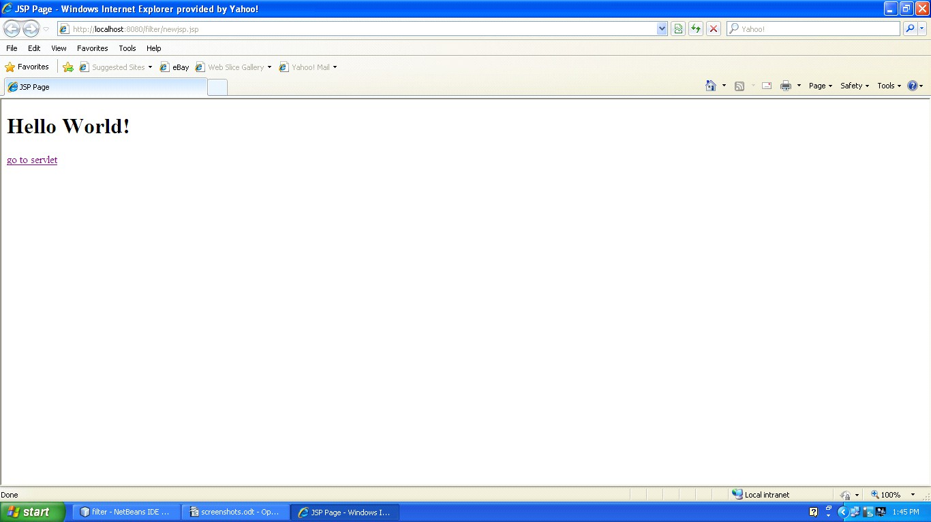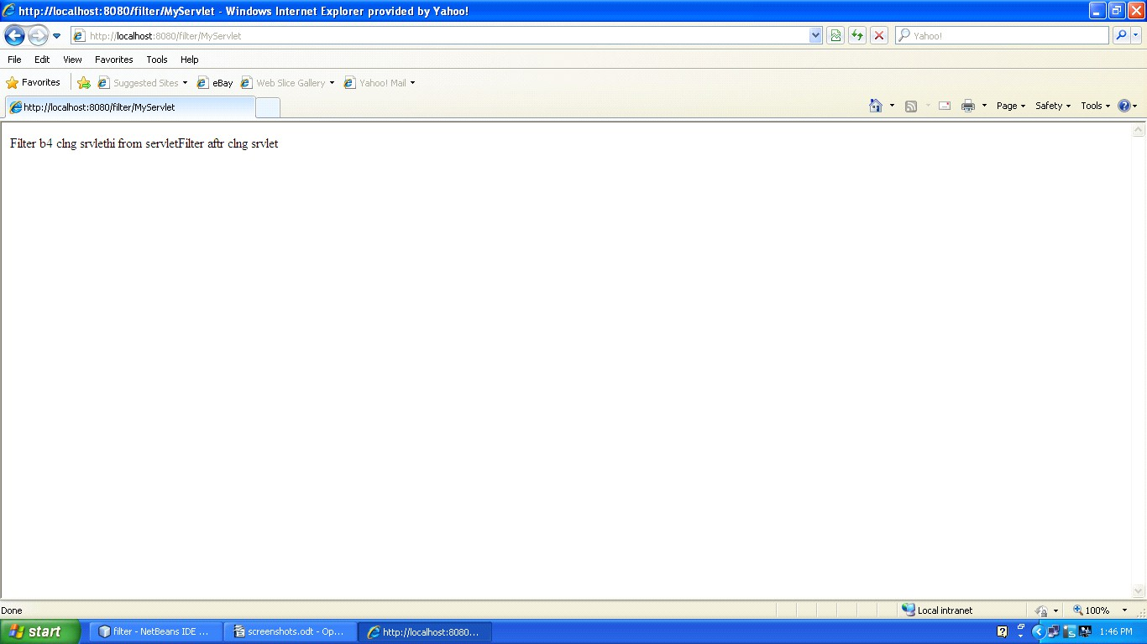

Logical Questions:

- What is the use of filterchain interface?
- .which are the applications of filter?

Practical 10

Aim: Write a program to implement useBean action tag.

Source Code:
JBeanEmpInfo.jsp
<%--
Document : JBeanAddEmpInfo Created on : Feb 25, 2016, 8:59:56 AM Author : faraahdabhoiwala
--%>
<%@page contentType="text/html" pageEncoding="UTF-8"%>
<!DOCTYPE html>
<html>
<head>
<meta http-equiv="Content-Type" content="text/html; charset=UTF-8">
<title>JSP Page</title>
</head>
<body>

<form method="post" action="JBeanViewEmpDetails.jsp"> Employee Code :<input type="text" name="empCode"> </input>
Employee Name :<input type="text" name="empName"> </input>
<input type="submit" value="submit">
</input>
</form>
</body>
</html>

JBeanEmpDetails.jsp
<%--
Document : JBeanViewEmpDetails Created on : Feb 25, 2016, 9:08:06 AM Author : faraahdabhoiwala
--%>
<%@page contentType="text/html" pageEncoding="UTF-8"%>
<!DOCTYPE html>
<html>
<head>

<meta http-equiv="Content-Type" content="text/html; charset=UTF-8">
<title>JSP Page</title>
</head>
<body>

<jsp:useBean id="emp" class="p1.JBean" />
<jsp:setProperty name="emp" property="*" />

<jsp:getProperty name="emp" property="empCode" />
<jsp:getProperty name="emp" property="empName" />
</body>
</html>

JBean.java package p1; import java.io.*;
/*
- To change this template, choose Tools | Templates
- and open the template in the editor.
*/
/**

- @author faraahdabhoiwala
*/
public class JBean implements Serializable { private String empCode;
private String empName; public String getEmpName()
{
return empName;
}
public void setEmpName(String empName)
{
this.empName=empName;
}
public String getEmpCode()
{
return empCode;
}
public void setEmpCode(String empCode)
{
this.empCode=empCode;
}

}

OUTPUT

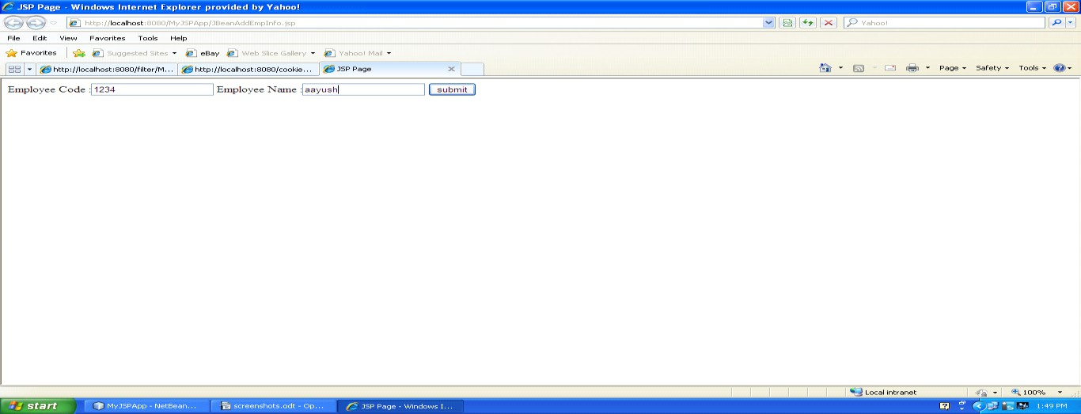
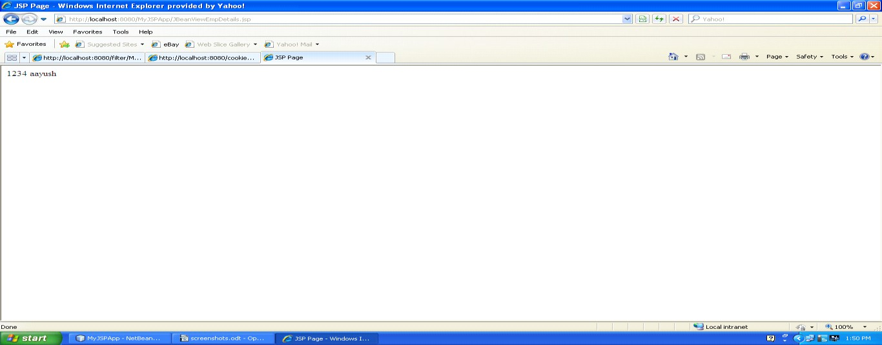
Logical Questions:
- What is the use of Serializable interface?
- .which are use os useBean action tag?

Practical 11

Aim: Write a program to create a Custom tag and use it in a JSP page.

Source Code: MyTagHandler.java
package p1;
import java.io.IOException; import javax.servlet.jsp.JspWriter;
import javax.servlet.jsp.JspException; import javax.servlet.jsp.tagext.JspFragment;
import javax.servlet.jsp.tagext.SimpleTagSupport;

public class MyTagHandler extends SimpleTagSupport { @Override
public void doTag() throws JspException ,IOException{ JspWriter out = getJspContext().getOut(); out.print("hello everyone this is custom tag");
}
}

Mytag_libraray.tld
<?xml version="1.0" encoding="UTF-8"?>
<taglib version="2.1" xmlns="http://java.sun.com/xml/ns/javaee" xmlns:xsi="http://www.w3.org/2001/XMLSchema-instance" xsi:schemaLocation="http://java.sun.com/xml/ns/javaee http://java.sun.com/xml/ns/javaee/web- jsptaglibrary_2_1.xsd">
<tlib-version>1.0</tlib-version>
<short-name>mytag_library</short-name>
<uri>/WEB-INF/tlds/Mytag_library</uri>
<tag>
<name>Display</name>
<tag-class>p1.MyTagHandler</tag-class>
<body-content>scriptless</body-content>
</tag>
</taglib>

CustomTag.java
<%@taglib prefix="f" uri="/WEB-INF/tlds/Mytag_library" %>
<%@page contentType="text/html" pageEncoding="UTF-8"%>
<!DOCTYPE html>

<html>
<head>
<meta http-equiv="Content-Type" content="text/html; charset=UTF-8">
<title>JSP Page</title>
</head>
<body>
<f:Display></f:Display>
</body>
</html>
OUTPUT
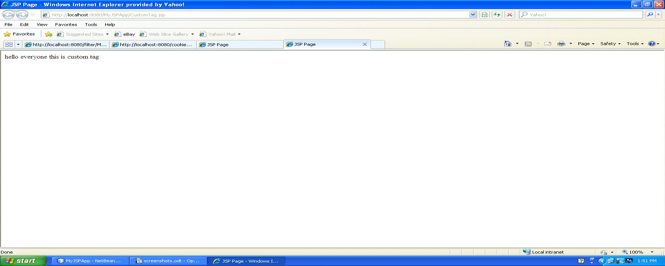

Logical Questions:

- Who catch the exceptions and which type of exceptions?
- Which are the use of custom tag?

Practical 12

Aim: Write a program using connectionless protocol in which the client sends a string to server and server converts the string into uppercase and sends it back to client.

Source Code: DatagramServer.java

/*
- To change this template, choose Tools | Templates
- and open the template in the editor.
*/
package mynetworkapp;
import java.net.*; import java.io.*;

/**

- @author faraahdabhoiwala
*/
public class DatagramServer {
/**
  - @param args the command line arguments
*/
public static void main(String[] args) {
// TODO code application logic here try{
DatagramSocket ds=new DatagramSocket(2000);//port no of socket--Socket Exception
byte b[]=new byte[100];
DatagramPacket dp=new DatagramPacket(b,b.length);//blank packet ds.receive(dp);
b=dp.getData();//unpack the datapacket//this statment throws IOException

String d=new String(b).trim();//convert to string System.out.println(d);
//task to be performed on string// String d1=d.toUpperCase();//task

System.out.println(d1);
//send the string back to the client

byte b1[]=new byte[100];//byte array for sending data b1=d1.getBytes();//convert string form data to bytes
DatagramPacket sp=new DatagramPacket(b1,b1.length,dp.getAddress(),dp.getPort()); ds.send(sp);//send the packet to client--throws IOException
} catch (Exception e) {
System.out.println(e);
}

}
}

DatagramClient.java
/*
- To change this template, choose Tools | Templates
- and open the template in the editor.
*/
package mynetworkapp;

import java.net.*; import java.util.Scanner;
/**

- @author faraahdabhoiwala
*/
public class DatagramClient {
/**
  - @param args the command line arguments
*/
public static void main(String[] args) {
// TODO code application logic here try {
DatagramSocket ds=new DatagramSocket();//thows SocketException Scanner sc=new Scanner(System.in);
System.out.print("Enter a String :");

String str=sc.next();
byte b[]=new byte[100]; b=str.getBytes();
//create a packet and store the data in it
DatagramPacket dp=new DatagramPacket(b,b.length,InetAddress.getLocalHost(),2000);
//send the packet ds.send(dp);
byte b1[]=new byte[100];
//create an empty packet to receive the data DatagramPacket rp=new DatagramPacket(b1,b1.length);
//fill the packet ds.receive(rp);
//unpack the data in byte form b1=rp.getData();
String d=new String(b1).trim(); System.out.println(d);

} catch (Exception e) {
System.out.println(e);
}
}
}

Logical Questions:

- What is connectionless protocol?
- Name of connectionless protocol.

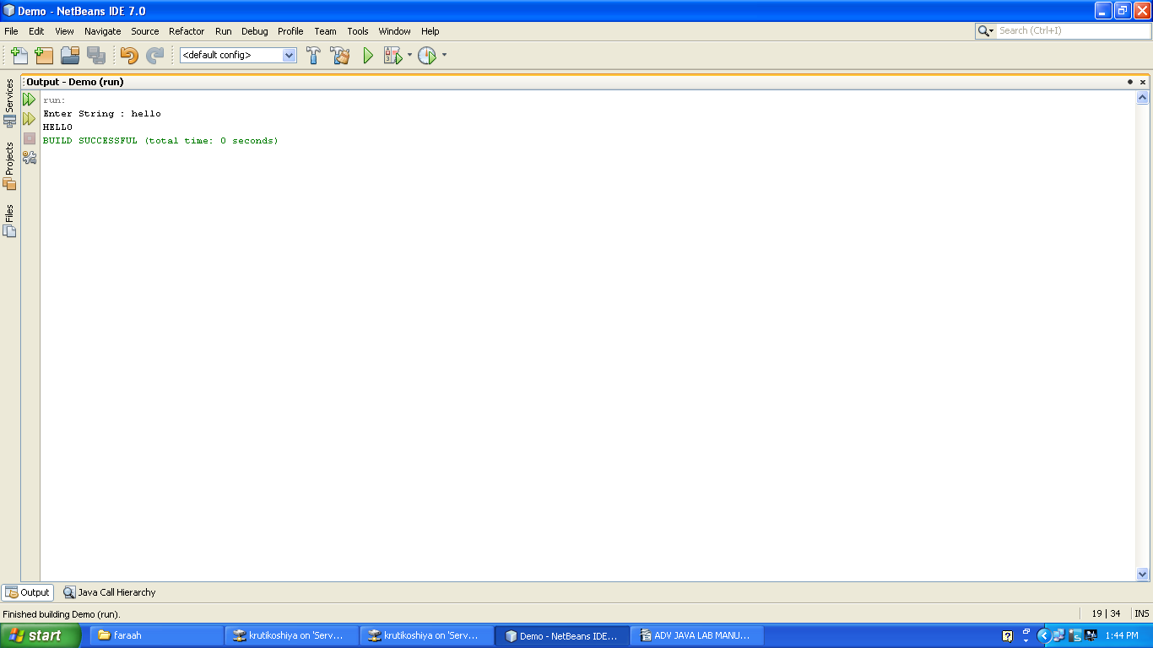

Practical 13

Aim: Write a JSF application to create a login form.

Source Code:
LoginBean.java
/*
- To change this template, choose Tools | Templates
- and open the template in the editor.
*/

/*
- To change this license header, choose License Headers in Project Properties.
- To change this template file, choose Tools | Templates
- and open the template in the editor.
*/
import java.io.Serializable; import java.sql.Connection; import java.sql.DriverManager; import java.sql.ResultSet; import java.sql.SQLException; import java.sql.Statement;
import javax.faces.bean.ManagedBean; import javax.faces.bean.SessionScoped;
/**

- @author user
*/
@ManagedBean(name = "loginBean")
//@Dependent @SessionScoped
public class LoginBean implements Serializable{ String userName;
String password;
public String getPassword() { return password;
}
public void setPassword(String password) { this.password = password;
}

public String getUserName() { return userName;
}

public void setUserName(String userName) { this.userName = userName;
}
public String checkValidUser()
{
try
{
Class.forName("sun.jdbc.odbc.JdbcOdbcDriver");
Connection con=DriverManager.getConnection("jdbc:odbc:TempDataSource","system","system");
Statement st=con.createStatement();

ResultSet rs=st.executeQuery("select * from user1 where username='"+userName+"' and password='"+password+"'");
rs.next();
if(rs.getRow()==1)
{
return "success";
}
else
{
return "failure";
}
}catch(Exception e)
{

return e.toString();
}

}
/*if(userName.equals("faraah") && password.equals("faraah")) return "success";
else
return "failure";*/

/**

* Creates a new instance of LoginBean
*/
public LoginBean() {
}

}
/*
import javax.faces.bean.ManagedBean; import javax.faces.bean.RequestScoped;

@ManagedBean @RequestScoped
public class LoginBean {

public LoginBean() {
}
}*/

login.jsp
<%--
Document : login
Created on : Mar 15, 2016, 9:33:42 AM Author : faraahdabhoiwala
--%>
<%@taglib uri="http://java.sun.com/jsf/core" prefix="f"%>
<%@taglib uri="http://java.sun.com/jsf/html" prefix="h"%>
<%@page contentType="text/html" pageEncoding="UTF-8"%>
<!DOCTYPE html>
<f:view>
<html>
<head>
<meta http-equiv="Content-Type" content="text/html; charset=UTF-8">
<title>JSP Page</title>
</head>
<h1>Hello World!</h1>
<body>
<h:form>
Enter UserName :<h:inputText id="userName" value="#{loginBean.userName}"><br/>

</h:inputText>
Enter Password : <h:inputText id="password" value="#{loginBean.password}"/><br/>
<h:commandButton value="login" action="#{loginBean.checkValidUser()}"/>
</h:form>

</body>
</html>
</f:view>

success.jsp
<%--
Document : success
Created on : Mar 15, 2016, 9:21:09 AM Author : faraahdabhoiwala
--%>
<%@page contentType="text/html" pageEncoding="UTF-8"%>
<!DOCTYPE html>
<html>
<head>
<meta http-equiv="Content-Type" content="text/html; charset=UTF-8">
<title>JSP Page</title>
</head>
<body>
<h1>login successful</h1>
</body>
</html>

failure.jsp
<%--
Document : failure
Created on : Mar 15, 2016, 9:21:21 AM Author : faraahdabhoiwala
--%>
<%@page contentType="text/html" pageEncoding="UTF-8"%>
<!DOCTYPE html>
<html>
<head>
<meta http-equiv="Content-Type" content="text/html; charset=UTF-8">
<title>JSP Page</title>
</head>
<body>
<h1>invalid username/pwd <br/>login failed</h1>
</body>
</html>

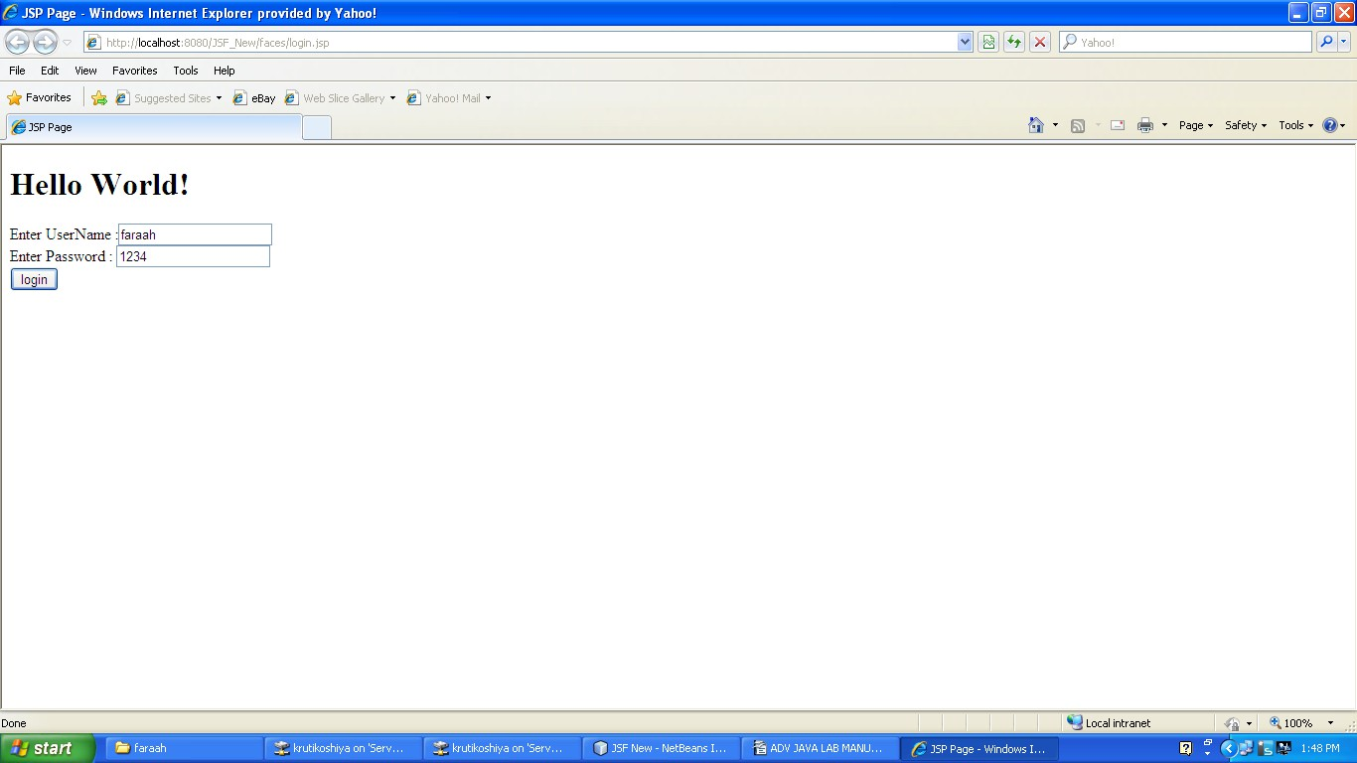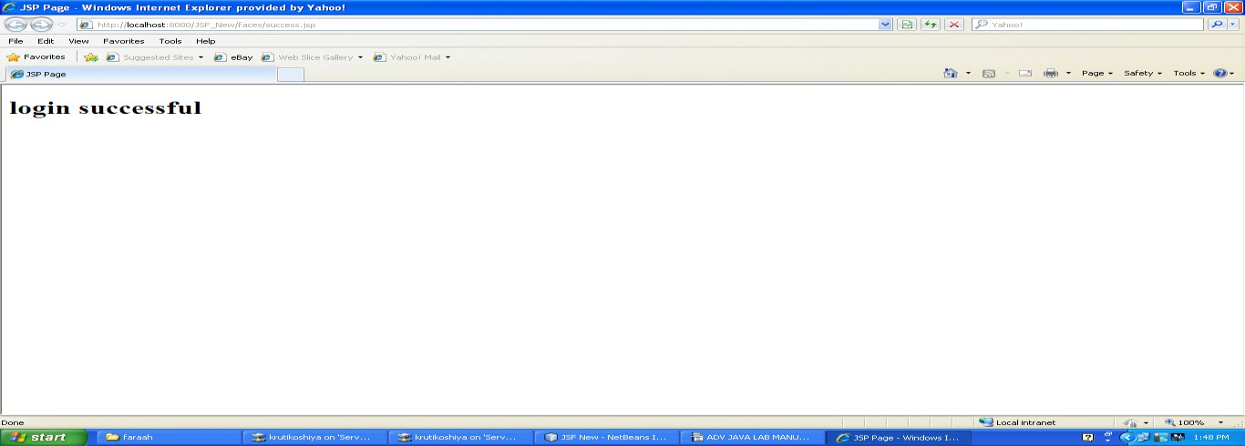

Logical Questions:

- What is the use of JSF?
- Which libreries required for JSF?

Practical 14

Aim: Write a JSF application to insert, update and delete record from database.

Source Code:
LoginBean.java
/*
- To change this template, choose Tools | Templates
- and open the template in the editor.
*/

/*
- To change this license header, choose License Headers in Project Properties.
- To change this template file, choose Tools | Templates
- and open the template in the editor.
*/
import java.io.Serializable; import java.sql.Connection; import java.sql.DriverManager; import java.sql.ResultSet; import java.sql.SQLException; import java.sql.Statement;
import javax.faces.bean.ManagedBean; import javax.faces.bean.SessionScoped;
/**

- @author user
*/
@ManagedBean(name = "loginBean")
//@Dependent @SessionScoped
public class LoginBean implements Serializable{ String userName;
String password;
public String getPassword() { return password;
}
public void setPassword(String password) { this.password = password;

}
public String getUserName() { return userName;
}
public void setUserName(String userName) { this.userName = userName;
}
public String checkValidUser()
{

try
{
Class.forName("sun.jdbc.odbc.JdbcOdbcDriver");
Connection con=DriverManager.getConnection("jdbc:odbc:TempDataSource","system","system");
Statement st=con.createStatement();

ResultSet rs=st.executeQuery("select * from user1 where username='"+userName+"' and password='"+password+"'");
rs.next();
if(rs.getRow()==1)
{
return "success";
}
else
{
return "failure";
}
}catch(Exception e)
{
return e.toString();
}

}
/*if(userName.equals("faraah") && password.equals("faraah")) return "success";
else
return "failure";*/

/**
* Creates a new instance of LoginBean
*/
public LoginBean() {
}
}
/*
import javax.faces.bean.ManagedBean; import javax.faces.bean.RequestScoped;

@ManagedBean @RequestScoped
public class LoginBean {

public LoginBean() {
}
}*/

login.jsp
<%--
Document : login
Created on : Mar 15, 2016, 9:33:42 AM Author : faraahdabhoiwala
--%>
<%@taglib uri="http://java.sun.com/jsf/core" prefix="f"%>
<%@taglib uri="http://java.sun.com/jsf/html" prefix="h"%>
<%@page contentType="text/html" pageEncoding="UTF-8"%>
<!DOCTYPE html>
<f:view>
<html>
<head>
<meta http-equiv="Content-Type" content="text/html; charset=UTF-8">
<title>JSP Page</title>
</head>
<h1>Hello World!</h1>
<body>
<h:form>
Enter UserName :<h:inputText id="userName" value="#{loginBean.userName}"><br/>
</h:inputText>
Enter Password : <h:inputText id="password" value="#{loginBean.password}"/><br/>
<h:commandButton value="login" action="#{loginBean.checkValidUser()}"/>

</h:form>
</body>
</html>
</f:view>

success.jsp
<%--
Document : success
Created on : Mar 15, 2016, 9:21:09 AM Author : faraahdabhoiwala
--%>
<%@page contentType="text/html" pageEncoding="UTF-8"%>
<!DOCTYPE html>
<html>
<head>
<meta http-equiv="Content-Type" content="text/html; charset=UTF-8">
<title>JSP Page</title>
</head>
<body>
<h1>login successful</h1>
</body>
</html>

failure.jsp
<%--
Document : failure
Created on : Mar 15, 2016, 9:21:21 AM Author : faraahdabhoiwala
--%>
<%@page contentType="text/html" pageEncoding="UTF-8"%>
<!DOCTYPE html>
<html>
<head>
<meta http-equiv="Content-Type" content="text/html; charset=UTF-8">
<title>JSP Page</title>
</head>
<body>
<h1>invalid username/pwd <br/>login failed</h1>
</body>
</html>

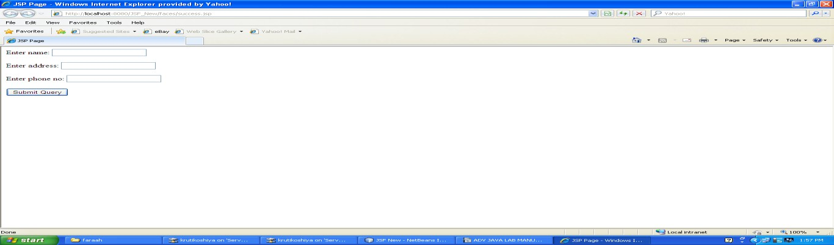
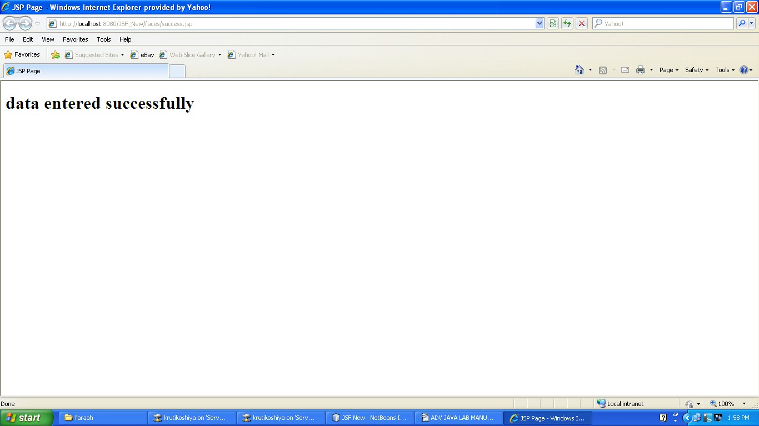

Logical Questions:

- How JSF application connect with Database?
- How data retrive from the database?

